Unit 2
Topic as per syllabus | As per Text Book
Multithreaded Programming: Overview, Multi-core Programming,  Multithreading Models, Implicit Threading, Threading Issues. | Chapter 4 Threads  4.1 Overview  4.2 Multicore Programming  4.3 Multithreading Models  4.4 Implicit Threading  4.6 Threading Issues
Process Scheduling: Basic concepts, Scheduling Criteria, Scheduling  Algorithms. Thread Scheduling, Multiple-Processor Scheduling, Real-Time  CPU Scheduling | Chapter 6 CPU Scheduling  6.1 Basic Concepts 261  6.2 Scheduling Criteria 264  6.3 Scheduling Algorithms 266  6.4 Thread Scheduling 277  6.5 Multiple-Processor Scheduling 278  6.6 Real-Time CPU Scheduling 283

  - Introduction
    - Motivation
    - Benefits
  - Multicore Programming
    - Programming Challenges
    - Types of Parallelism
  - Multithreading Models
    - Many-to-One Model
    - One-to-One Model
    - Many-to-Many Model
  - Implicit Threading
    - Thread Pools
    - OpenMP
    - Grand Central Dispatch
    - Other Approaches
  - Threading Issues
    - The fork() and exec() System Calls
    - Signal Handling
    - Cancellation
    - Thread-Local Storage
    - Scheduler Activations

INTRODUCTION:
A thread is the basic unit of CPU utilization, comprising a thread ID, program counter, register set, and stack. Threads belonging to the same process share key components such as the code section, data section, and various operating system resources, including open files and signals. While a traditional (or heavyweight) process has only a single thread of control, a multi-threaded process can perform multiple tasks simultaneously, enabling improved efficiency and concurrency. Figure 4.1 shows the contrast between a single- threaded process and a multithreaded process.
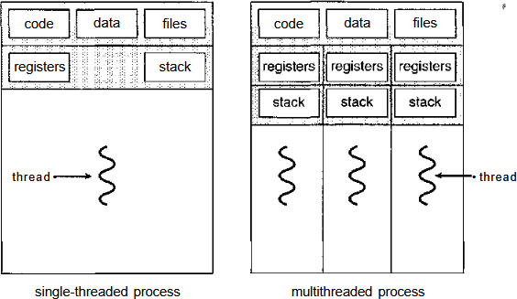

Figure 4.1 Single-threaded and multithreaded processes.

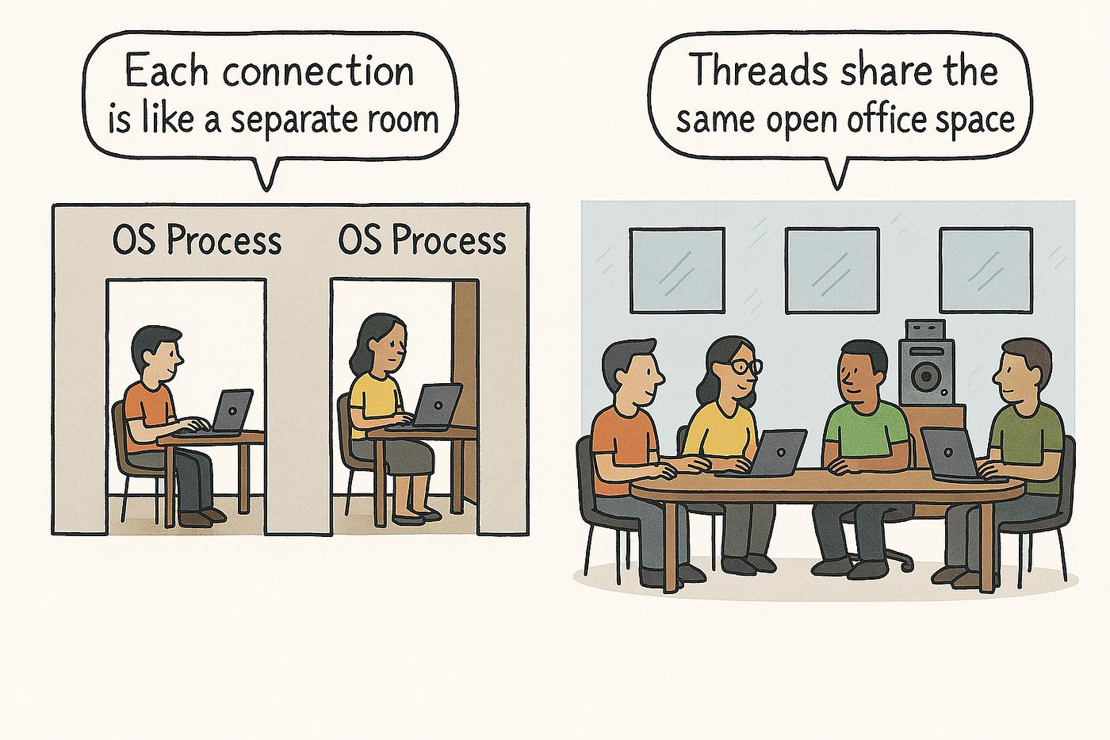

Resource | Shared / Not Shared
Code | Shared
Data & Heap | Shared
Stack | ❌ Not Shared
Registers | ❌ Not Shared
Program Counter | ❌ Not Shared
Thread ID | ❌ Not Shared
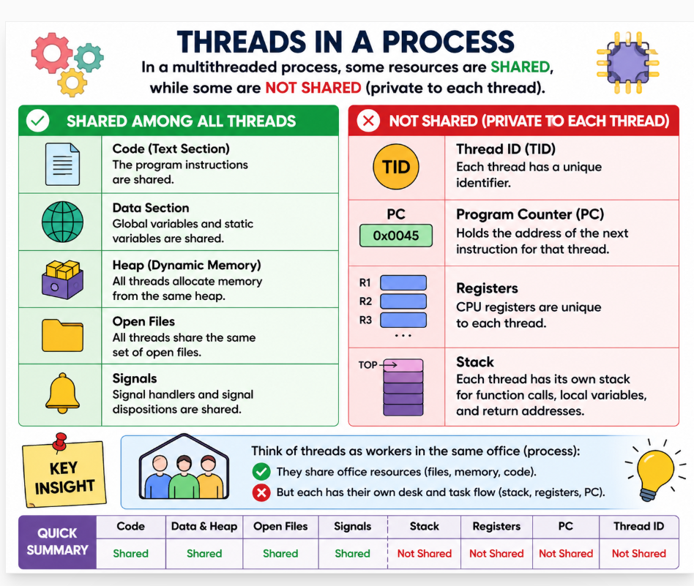

Motivation
Modern software packages commonly utilize multithreading to manage multiple tasks within a single process. For instance, a web browser may use one thread to display content while another retrieves data from the network. Similarly, a word processor might allocate threads for displaying graphics, processing keystrokes, and running spelling or grammar checks in the background.
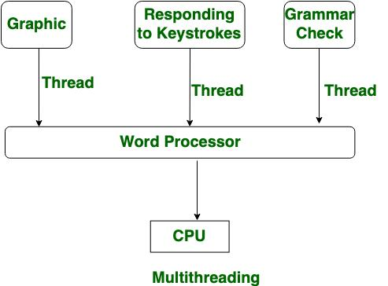
Multithreading is crucial for applications like web servers, which must handle numerous client requests simultaneously. A single-threaded server can process only one client request at a time, leading to delays during periods of high demand. By creating a new thread for each request, multithreading minimizes the overhead associated with creating separate processes, enabling efficient handling of thousands of simultaneous client requests.

Remote Procedure Call (RPC) systems also benefit from multithreading, as servers can handle multiple requests concurrently, with each request managed by a separate thread.

Moreover, modern operating system kernels, such as those in Solaris and Linux, leverage multithreading to improve system performance by dedicating threads to tasks like device management and interrupt handling.

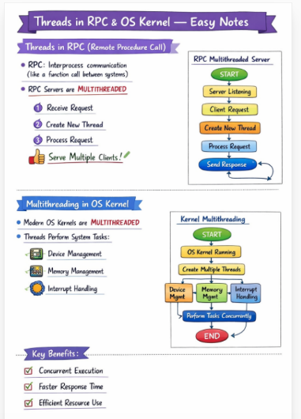
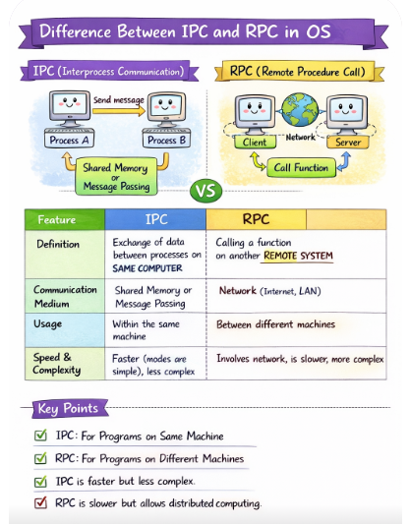

Benefits
The benefits of multithreaded programming can be broken down into four major categories:
- Responsiveness: Multithreading helps keep applications responsive. For example, a multithreaded web browser can still allow user interactions in one thread while loading an image in another, preventing delays during lengthy tasks.
- Resource Sharing: Threads within the same process share memory and resources, allowing them to work within the same address space and improving resource utilization.
- Economy: Threads are less resource-intensive than processes, making them more economical to create and manage. For example, in Solaris, creating a process is about 30 times slower than creating a thread.
- Utilization of multiprocessor architectures: On multiprocessor systems, multithreading allows threads to run on multiple CPUs, boosting performance by enabling parallel execution.
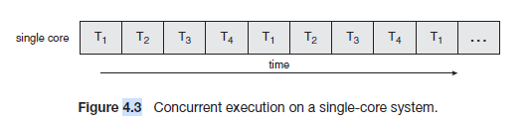

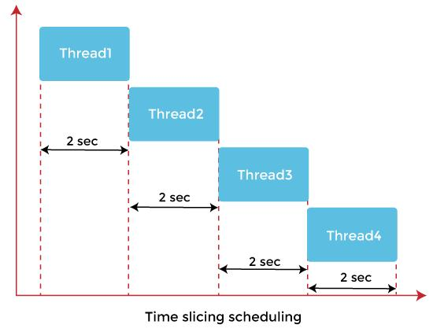
• A single-core CPU can execute only ONE thread at a time
• But it gives an illusion of parallel execution using context switching
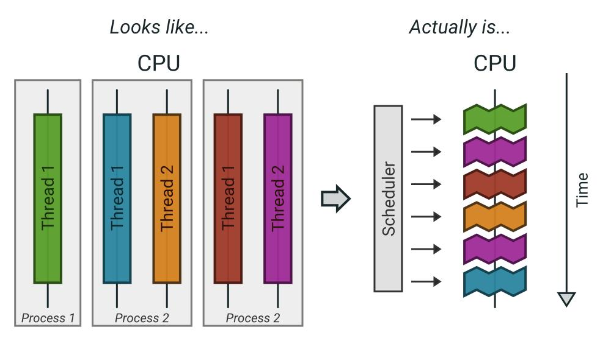

Multicore Programming

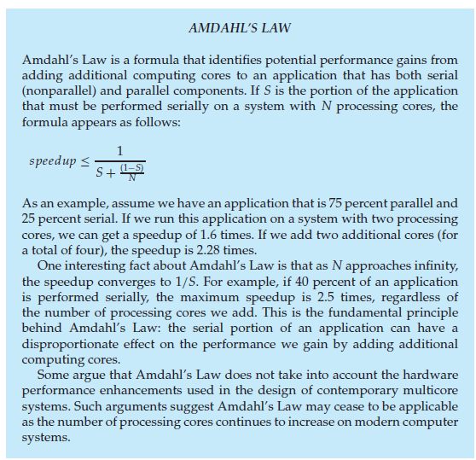

Table 1: Introduction to Amdahl’s Law
Section | Explanation
What is Amdahl’s Law? | Amdahl’s Law explains how much performance improvement (speedup) can be achieved when more CPU cores/processors are added.
Core Idea | Not all parts of a program can run in parallel. Some parts execute sequentially (serial part), while others execute simultaneously (parallel part).
Important Concept | Even if many processors are added, the serial part limits the overall speedup.
Formula | 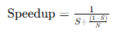

Table 2: Meaning of Terms & Program Portions

Symbol / Concept | Meaning / Explanation
S | Serial portion of the program
1 − S | Parallel portion of the program
N | Number of processors/cores
Speedup | Overall performance improvement
🔹 Serial Part | Cannot be parallelized; executes sequentially
🔹 Examples of Serial Part | Reading input sequentially, merging results, critical sections
🔹 Parallel Part | Can run simultaneously on multiple cores
🔹 Examples of Parallel Part | Matrix multiplication, image processing, sorting chunks of data
Key Insight | Even a very small serial portion can greatly reduce overall speedup

Table 3: Example, Infinite Processors & Analogy
Section | Explanation
Given Example | Parallel = 75%, Serial = 25%, Number of cores = 2
Calculation (2 cores) | 
Observation | Using 2 cores gives only 1.6× speedup, not 2×
Calculation (4 cores) | 
Observation | Even with 4 cores, speedup is only about 2.28×
Infinite Processors Case | 
Maximum Speedup Formula | 
Example | 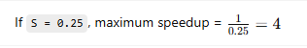
Final Observation | Even with infinite processors, speedup cannot exceed 4
Pizza Shop Analogy | One chef prepares dough (serial work), many chefs add toppings (parallel work). Dough preparation becomes the bottleneck.
Final Conclusion | The serial portion limits the maximum performance improvement achievable by adding processors.

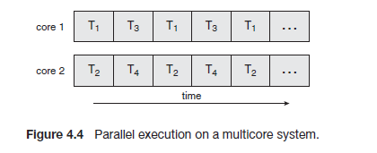

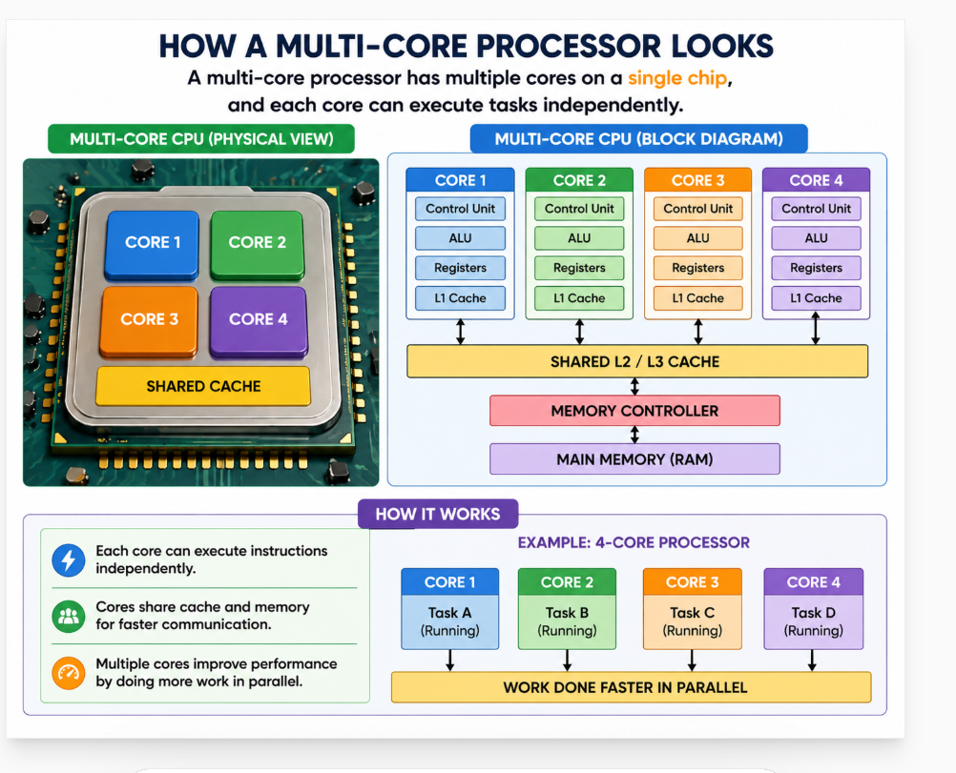

Category | Example Machine / Processor | Number of Cores (Approx.) | Usage
Laptop / PC | Intel Core i4 | 4–10 cores | General computing
Laptop / PC | AMD Ryzen 7 | 8+ cores | Multitasking, development
Smartphone | Apple A17 Bionic | 6 cores | Mobile apps, gaming
Smartphone | Snapdragon 8 Gen 3 | 8 cores | High-end smartphones
Server | Intel Xeon | 16–64+ cores | Data centers, cloud
Server | AMD EPYC | 32–96 cores | High-performance computing
Gaming Console | PlayStation 4 | 8 cores | Gaming
Gaming Console | Xbox Series X | 8 cores | Gaming

Earlier in the history of computer design, in response to the need for more computing performance, single-CPU systems evolved into multi-CPU systems. A more recent, similar trend in system design is to place multiple computing cores on a single chip. Each core appears as a separate processor to the operating Whether the cores appear across CPU chips or within CPU chips, we call these systems multicore or multiprocessor systems.

Multithreaded programming provides a mechanism for more efficient use of these multiple computing cores and improved concurrency. Consider an application with four threads. On a system with a single computing core, concurrency merely means that the execution of the threads will be interleaved over time because the processing core is capable of executing only one thread at a time. On a system with multiple cores, however,

Concurrency means that the threads can run in parallel, because the system can assign a separate thread to each core .Notice the distinction between parallelism and concurrency in this discussion. A system is parallel if it can perform more than one task simultaneously. In contrast, a concurrent system supports more than one task by allowing all the tasks to make progress.

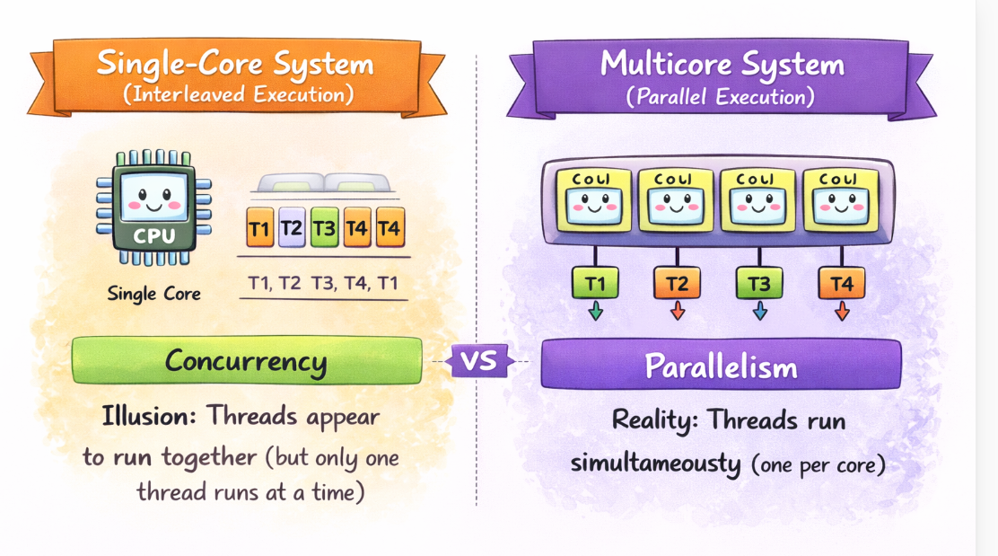

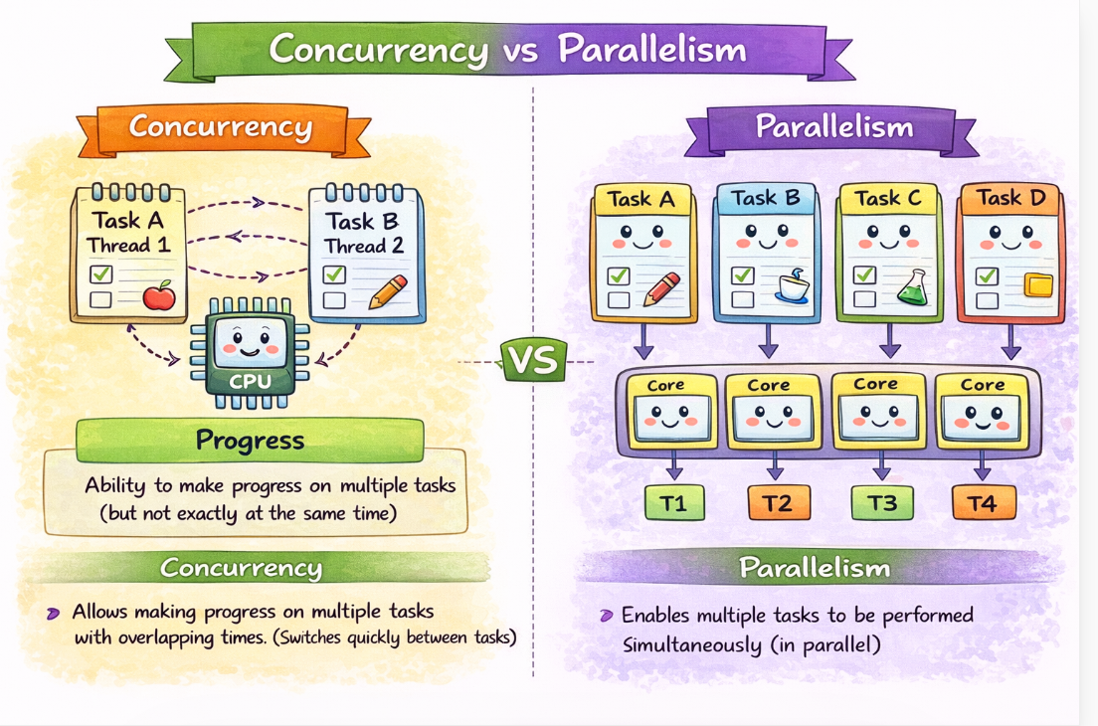

Programming Challenges
- Identifying tasks. This involves examining applications to find areas
that can be divided into separate, concurrent tasks. Ideally, tasks are
independent of one another and thus can run in parallel on individual
cores.
2. Balance. While identifying tasks that can run in parallel, programmers
must also ensure that the tasks perform equal work of equal value. In
some instances, a certain task may not contribute as much value to the
overall process as other tasks. Using a separate execution core to run that
t ask may not be worth the cost.
3. Data splitting. Just as applications are divided into separate tasks, the
data accessed and manipulated by the tasks must be divided to run on
separate cores.
4. Data dependency. The data accessed by the tasksmust be examined for
dependencies between two or more tasks. When one task depends on
data from another, programmers must ensure that the execution of the
tasks is synchronized to accommodate the data dependency.We examine
s uch strategies in Chapter 4.
4. Testing and debugging. When a program is running in parallel on
multiple cores, many different execution paths are possible. Testing and
debugging such concurrent programs is inherently more difficult than testing and debugging single-threaded applications.

Types of Parallelism

Parallelism is divided into data parallelism and task parallelism.

Data parallelism involves distributing portions of data across multiple cores, with each core executing the same operation on different data subsets. This is useful for operations like array processing.

Task parallelism, on the other hand, distributes different computational tasks across cores, where each thread may perform distinct operations on the same or different data. Many modern applications employ a hybrid approach, using both forms to maximize efficiency. These parallelism models are crucial in fields like machine learning, simulation, and large-scale computing, where workload distribution greatly impacts performance

Data parallelism

Same data divided into parts

• Same operation applied on each part

• Runs on multiple cores simultaneously

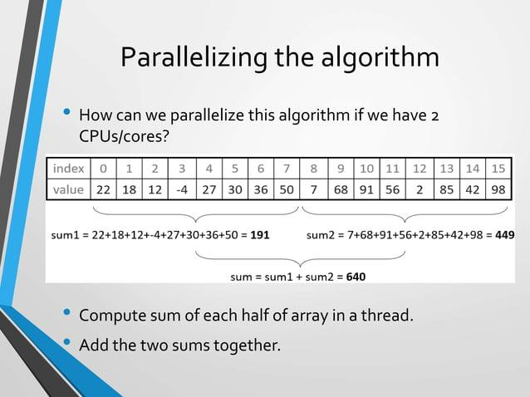

Task parallelism

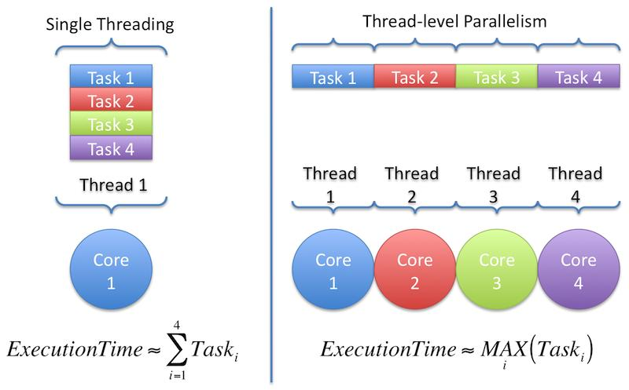
Different tasks (threads) assigned to cores
• Each thread performs different operation
• May use same or different data
Example:
• Thread 1 → Mean calculation
• Thread 2 → Variance calculation
Focus: Task distribution

Feature | Data Parallelism | Task Parallelism
Focus | Data | Tasks
Operation | Same | Different
Data Used | Different parts | Same / Different
Example | Array split | Different computations

How to Identify Task vs Data Parallelism
- Task Parallelism
Different threads perform different tasks/operations
Focus is on what work is done
- Data Parallelism
Same operation is performed on different parts of data
Focus is on how data is divided

Application / Example | Type | Justification
Multithreaded Statistical Program | Data Parallelism | Same computation on different data sets
Multithreaded Sudoku Validator | Task Parallelism | Threads check rows, columns, and subgrids
Multithreaded Sorting Program | Data Parallelism | Same sorting applied to different subarrays
Multithreaded Web Server | Task Parallelism | Each thread handles a different request
Image Processing | Data Parallelism | Same operation on different pixels
Matrix Multiplication | Data Parallelism | Same computation on different elements
Compiler Phases | Task Parallelism | Different stages perform different tasks
Video Streaming Server | Task Parallelism | Each thread serves a different user

Multithreading Models:

Threads can be implemented at two levels: user-level threads and kernel-level threads. User threads are managed at the application level without direct support from the operating system, while kernel threads are directly managed and supported by the operating system. Most modern operating systems, such as Windows XP, Linux, macOS, Solaris, and Tru64 UNIX, provide support for kernel threads.
To enable user threads to work effectively with kernel threads, a relationship between the two must be established. This integration is typically achieved through one of three common models.

User threads are managed at the application level without OS support, whereas kernel threads are directly managed and scheduled by the operating system

Aspect | Kernel Threads | User Threads
Management | Managed by OS (kernel) | Managed by user-level library
Number Limit | Limited by OS and system resources | Can be created in large numbers
Execution | Only limited threads run based on cores | Mapped onto kernel threads for execution
Parallelism | True parallelism possible | Depends on mapping to kernel threads
Core Usage | One (or few with SMT) per core at a time | Many exist but only few execute at a time
Scheduling | Done by OS scheduler | Done by user-level scheduler
Performance | Higher overhead (system calls) | Lower overhead (no kernel involvement)
Limitation | Limited in number | Not strictly limited, but execution is constrained

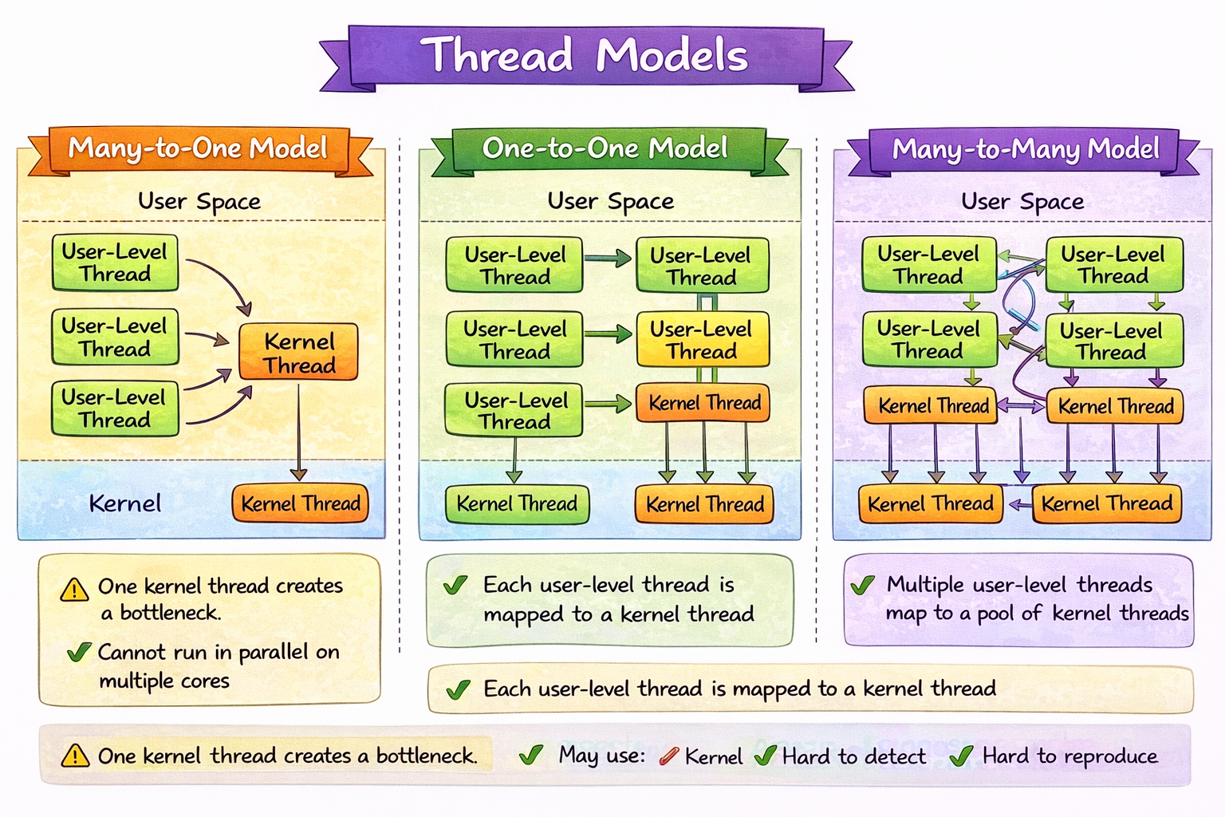

Many-to-One Model
The many-to-one model (Figure 4.2) maps multiple user-level threads to a single kernel thread, managed by a user-space thread library. While efficient, this model has limitations: if one thread makes a blocking system call, the entire process is blocked, and only one thread can access the kernel at a time, preventing parallel execution on

multiprocessor systems. Examples include the Green Threads library in Solaris and GNU Portable Threads

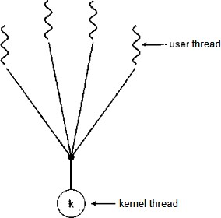
.

Figure 4.2 Many-to-one model

    - One-to-One Model
The one-to-one model (Figure 4.3) maps each user thread to a separate kernel thread, enabling high concurrency by allowing other threads to run if one is blocked and supporting parallel execution on multiprocessors. However, the model requires creating a kernel thread for each user thread, which can lead to overhead. To manage performance, implementations of this model often limit the number of threads. This model is used by Linux and the Windows family, including Windows 94, 98, NT, 2000, and XP.
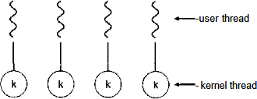

Figure 4.3 One-to-one mode

    - Many-to-Many Model
The many-to-many model (Figure 4.4) multiplexes many user-level threads onto a smaller or equal number of kernel threads, with the number of kernel threads varying by application or system. This model balances flexibility and concurrency, as it allows multiple threads to run simultaneously on multiprocessors. While the many-to-one model offers unlimited user threads, it lacks true concurrency, and the one-to-one model offers better concurrency but may limit the number of threads. The many-to-many model seeks to combine the benefits of both, allowing efficient thread management without overloading the system.

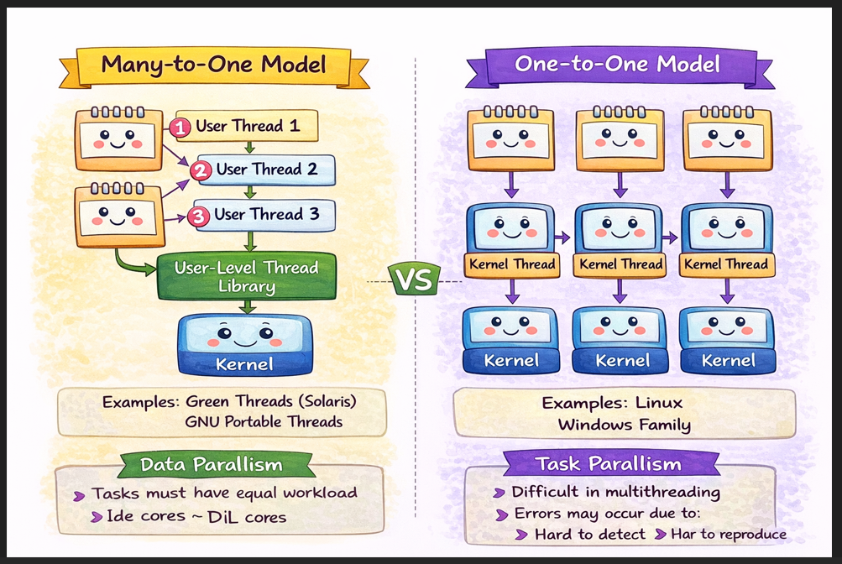

The many-to-many model overcomes the limitations of other models by allowing developers to create numerous user threads, which can run in parallel on multiprocessors. When a thread makes a blocking system call, the kernel can schedule another thread. A variation of this model, known as the two-level mode (Figure 4.4) l, multiplexes user threads to kernel threads but allows binding specific user threads to kernel threads. This model, used by systems like IRIX, HP-UX, and Tru64 UNIX, provides more flexibility. Solaris used the two-level model before version 9 but now uses the one-to-one model.
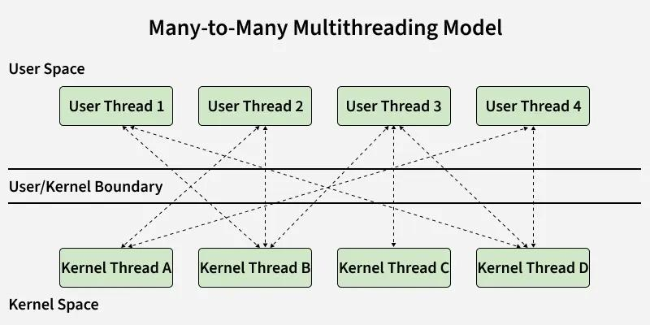

Parallelism depends on number of kernel threads, not user threads

Model | Mapping | Real-World Example | Parallelism | Justification
Many-to-One | Many user threads → One kernel thread | Early Java (green threads), simple scripting runtimes | ❌ No | Only one kernel thread executes, so even on multicore systems, only one thread runs at a time
One-to-One | One user thread → One kernel thread | Windows threads, Linux pthreads | ✅ Yes | Each thread is handled by OS, allowing true parallel execution on multiple cores
Many-to-Many | Many user threads → Many kernel threads | Modern systems (e.g., Solaris, Go runtime model similar concept) | ✅ Yes | Multiple kernel threads allow parallelism while efficiently managing many user threads

Performance Implications (Many-to-Many Model)

Case | Kernel Threads vs Cores | Performance | Justification
(a) | Kernel threads < cores | Low performance | Some cores remain idle, leading to underutilization of CPU resources
(b) | Kernel threads = cores | Best performance | All cores are fully utilized with no unnecessary overhead
(c) | Kernel threads > cores but < user threads | Moderate performance | All cores are used, but extra kernel threads cause context switching overhead

Implicit Threading
With the growth of multicore processors, modern applications use multiple threads to improve performance by executing tasks in parallel. However, manually creating and managing a large number of threads is complex and challenging. Programmers must handle synchronization, avoid issues like race conditions and deadlocks, and ensure correctness, which makes the design process difficult, error-prone, and hard to scale with increasing cores.
To overcome these challenges, implicit threading is used, where the responsibility of thread management is shifted to the compiler and runtime system. In this pproach, programmers write simple or high-level code, while the system automatically creates threads, distributes tasks across cores, and manages synchronization. This reduces complexity, minimizes errors, improves scalability, and ensures efficient utilization of multicore processors.

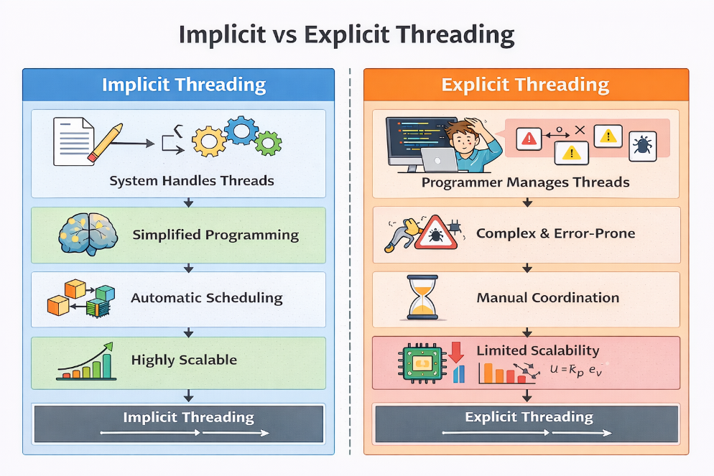

4.3.1 Thread Pools
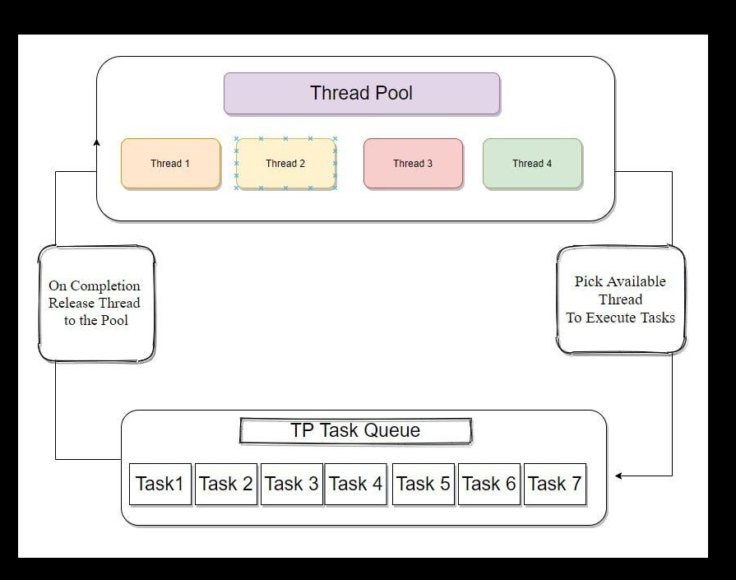
Thread pools are a technique used to improve the efficiency of multithreaded applications. Instead of creating a new thread for every incoming task, a fixed number of threads are created at the beginning of program execution and stored in a pool. These threads remain idle until tasks arrive. When a request is received, an available thread from the pool is assigned to handle the task, and once completed, the thread returns to the pool for reuse.
This approach reduces the overhead of thread creation and destruction, which can be time-consuming. It also prevents excessive thread creation that could exhaust system resources such as CPU and memory. Thread pools improve performance, scalability, and resource management.
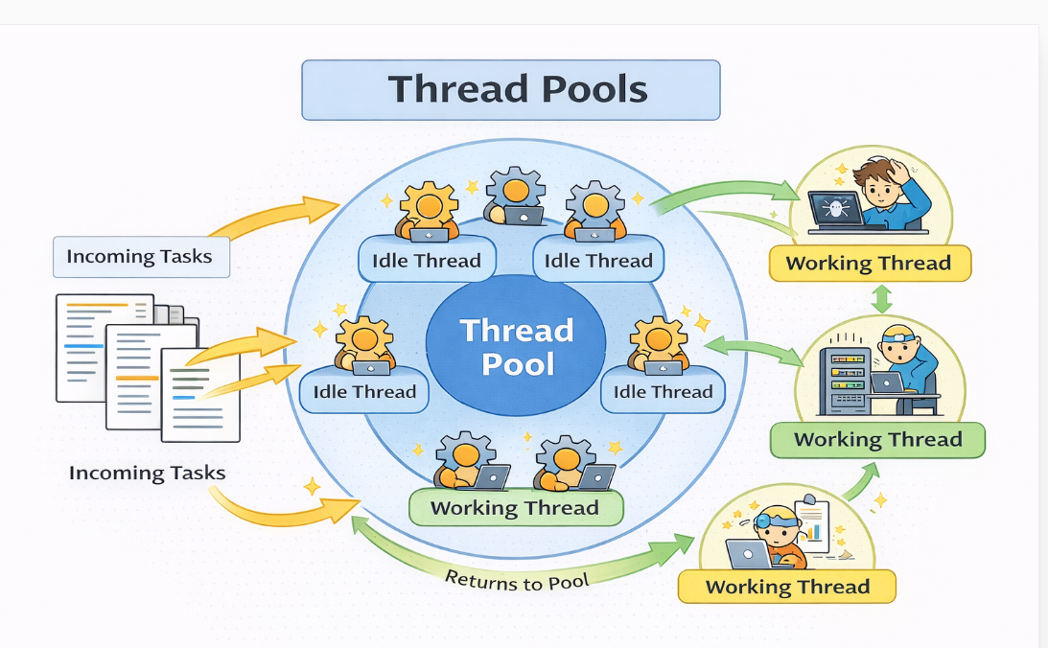
Thread pools offer these benefits:
1. Servicing a request with an existing thread is faster than waiting to create a thread.
2. A thread pool limits the number of threads that exist at any one point. This is particularly important on systems that cannot support a large number of concurrent threads.
3. Separating the task to be performed from the mechanics of creating the task allows us to use different strategies for running the task. For example, the task could be scheduled to execute after a time delay or to execute periodically.

4.4.2 OpenMP
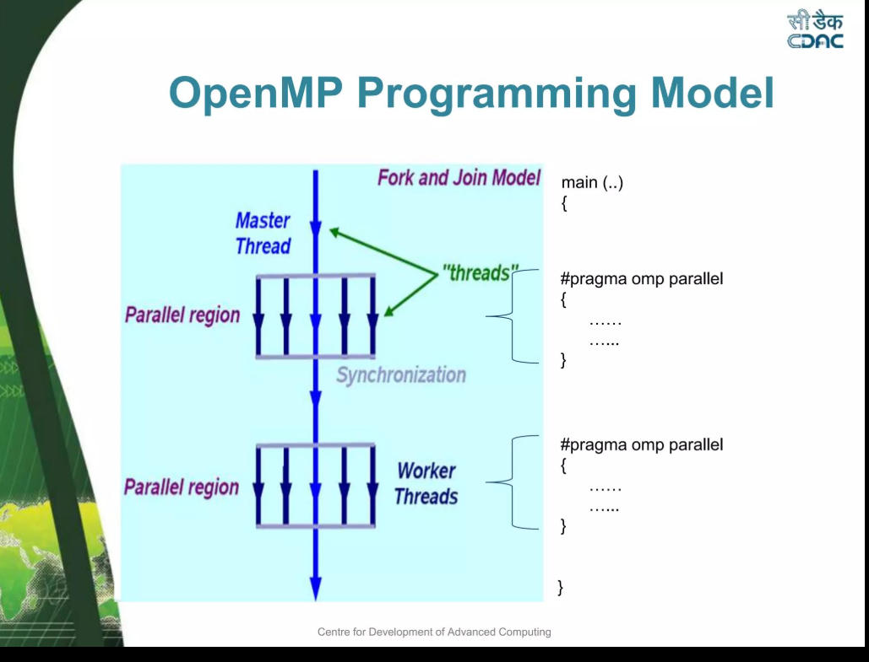
OpenMP (Open Multi-Processing) is an API (Application Programming Interface) used for parallel programming in shared-memory systems
OpenMP lets you convert a normal (sequential) program into a parallel program by adding a few special instructions.
OpenMP is an API and set of compiler directives used for parallel programming in shared-memory systems. It allows developers to specify parallel regions in a program using simple directives, rather than manually creating and managing threads. When the compiler encounters an OpenMP directive, it automatically creates multiple threads based on the number of available processor cores.

Each thread executes the parallel region simultaneously, and once execution is complete, the threads are terminated. OpenMP simplifies parallel programming by abstracting thread management and allowing programmers to focus on logic rather than low-level details
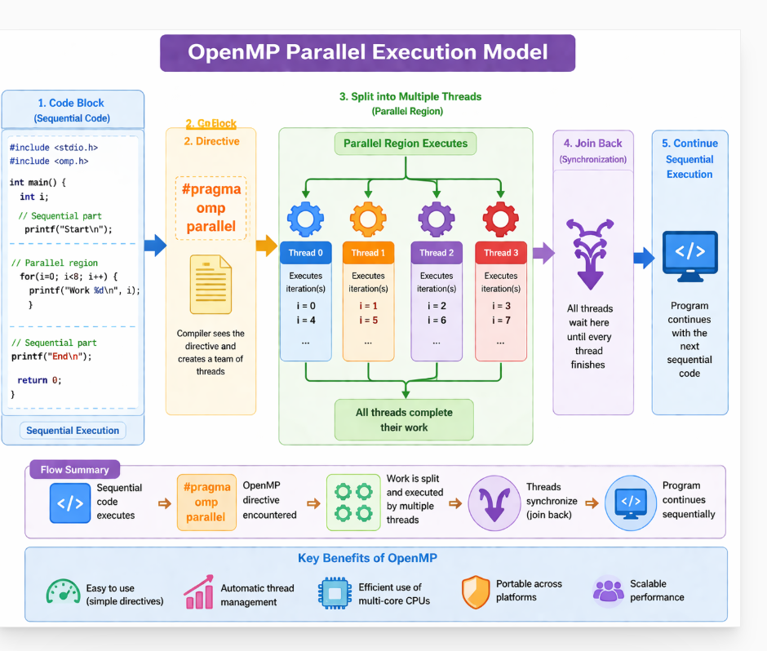

4.4.3 Grand Central Dispatch
Grand Central Dispatch (GCD) is a technology developed by Apple for managing concurrent execution. Instead of explicitly creating threads, developers submit tasks to dispatch queues. The system then automatically schedules and executes these tasks using a pool of threads.
GCD dynamically manages thread creation and workload distribution based on system conditions. It improves efficiency by balancing load and reducing overhead. Developers only need to define tasks, and GCD ensures optimal execution, making it a powerful implicit threading model.
Think of GCD like a taxi booking app:
- You → request a ride (task)
- App → assigns a driver (thread)
- You don’t care:
  - which driver comes
  - how many drivers exist
  - how routes are managed
The system handles everything automatically.

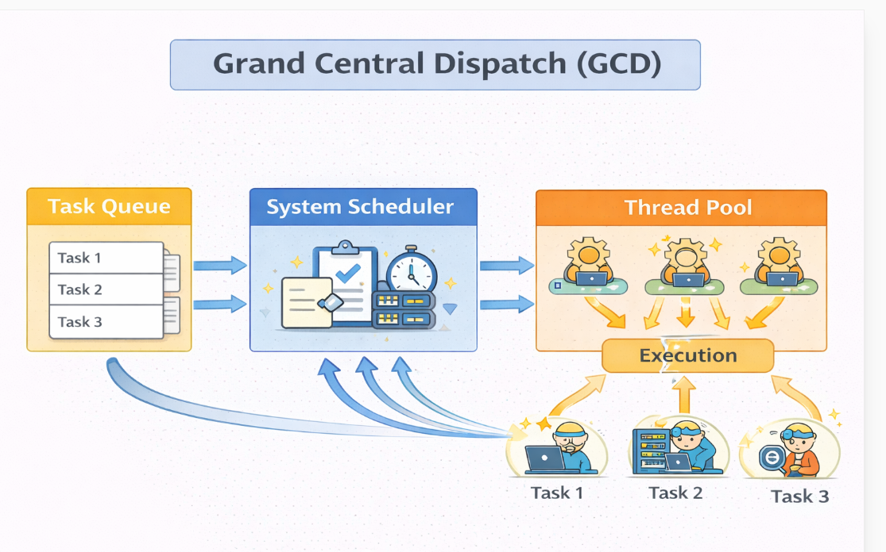
4.4.4 Other Approaches
Thread pools, OpenMP, and Grand Central Dispatch are just a few of many
emerging technologies for managing multithreaded applications. Other commercial
approaches include parallel and concurrent libraries, such as Intel’s Threading Building Blocks (TBB) and several products from Microsoft.The Java language and API have seen significant movement toward supporting concurrent programming as well. A notable example is the java.util.concurrent package, which supports implicit thread creation and management

  - Threading Issues.

Threading issues refer to the challenges in managing multiple threads, including synchronization, resource sharing, communication, and system-level concerns like signal handling and process creation.

    - The fork() and exec() System Calls
In a multithreaded program, the behavior of the fork() system call changes. When fork() is called, some UNIX systems offer two versions: one duplicates all threads, and the other duplicates only the calling thread. If exec() is called immediately after fork(), duplicating only the calling thread is efficient, as exec() replaces the entire process. However, if exec() is not used, duplicating all threads may be necessary for the separate process to maintain the program’s functionality
- After fork(), the parent process remains unchanged, while the child process may contain either only the calling thread or all threads;
- After fork(), the parent remains unchanged and the child gets either one or all threads, while exec() replaces the entire process and results in a single-threaded program.

Step | Parent | Child
Before fork | Multiple threads | —
After fork | Same threads | One OR all threads
After exec | — | Only new program (single thread)

    - Signal Handling
In UNIX systems, signals are used to notify processes of specific events. Signals can be received either synchronously or asynchronously, depending on the event's source. The signal handling process follows a consistent pattern:
- A signal is triggered by an event.
- The signal is delivered to the relevant process.
- The signal must then be handled by the process.
Synchronous signals, such as illegal memory access or division by zero, are generated by operations within the process and are delivered to the same process. Asynchronous signals, such as those triggered by external events like keystrokes or timers, are delivered to processes other than the one causing the event. Each signal can be handled by a default handler or a user-defined handler.
In a multithreaded environment, signals generated by external events are delivered asynchronously. Examples include terminating a process with keystrokes like
<Control><C> or when a timer expires. These signals can be handled by either a default handler or a user-defined handler. The default handler is invoked by the kernel, but users can override it with a custom handler.
In single-threaded programs, signals are straightforward to handle, as they are delivered to the process. However, in multithreaded programs, where multiple threads exist, deciding where to deliver the signal becomes more complex. Signals can be delivered to a specific thread, all threads, selected threads, or even a dedicated thread. Synchronous signals are delivered to the thread that caused them, while asynchronous signals, like process termination, are often sent to all threads. UNIX systems allow threads to specify which signals to accept or block, and signals are typically delivered to the first thread that is not blocking them. In contrast, Windows doesn't have built-in signal support, but emulates them using Asynchronous Procedure Calls (APCs), which are delivered to specific threads.
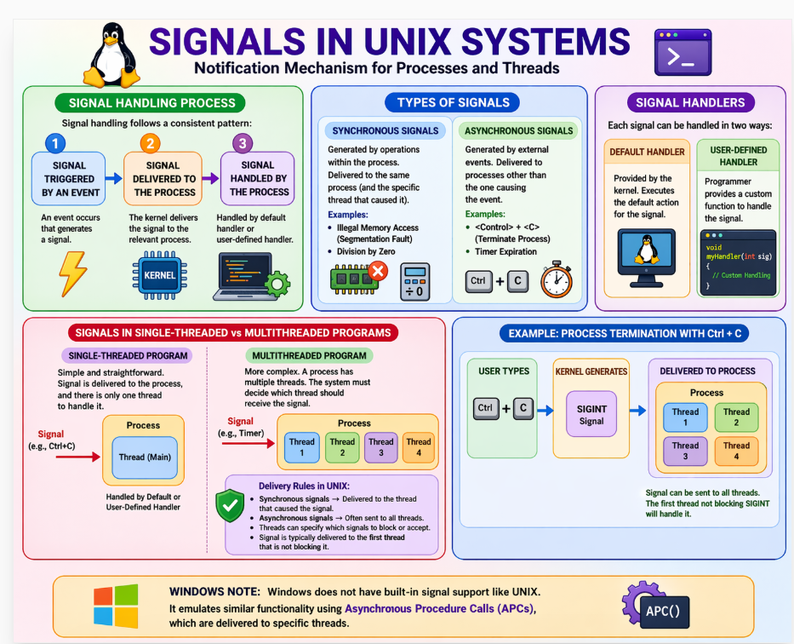
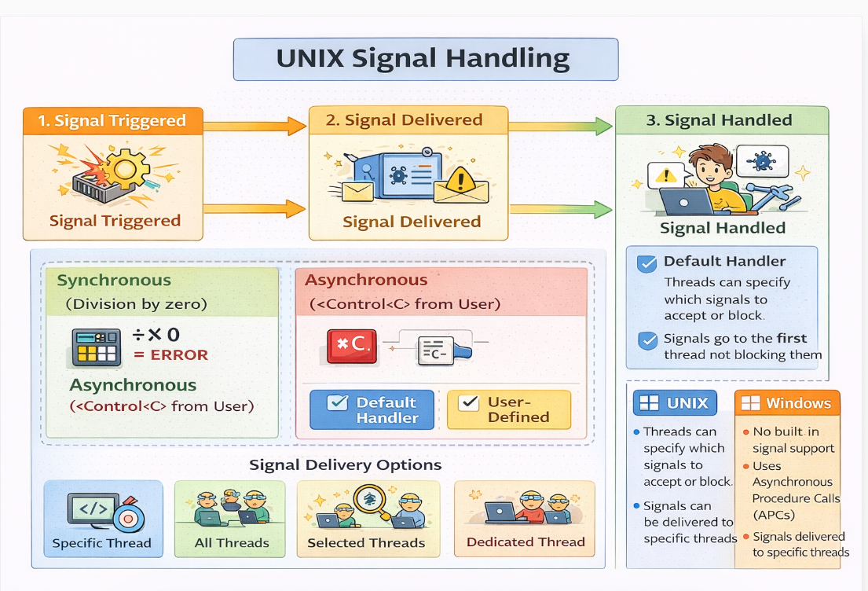
A process is like a company, threads are workers performing tasks, and signals are notifications or events that interrupt execution and must be handled by a thread.

    - Cancellation
Thread cancellation involves stopping a thread before it completes its task. For instance, if multiple threads are searching a database and one finds the result, the others can be canceled. Cancellation can be either:
- Asynchronous cancellation: The target thread is terminated immediately by another thread.
- Deferred cancellation: The target thread periodically checks if it should terminate, allowing it to exit safely.
Asynchronous cancellation can lead to resource issues, as canceled threads may not release all resources properly. Deferred cancellation, by contrast, allows threads to stop at designated safe points known as cancellation points in Pthreads, ensuring resource safety and consistency.
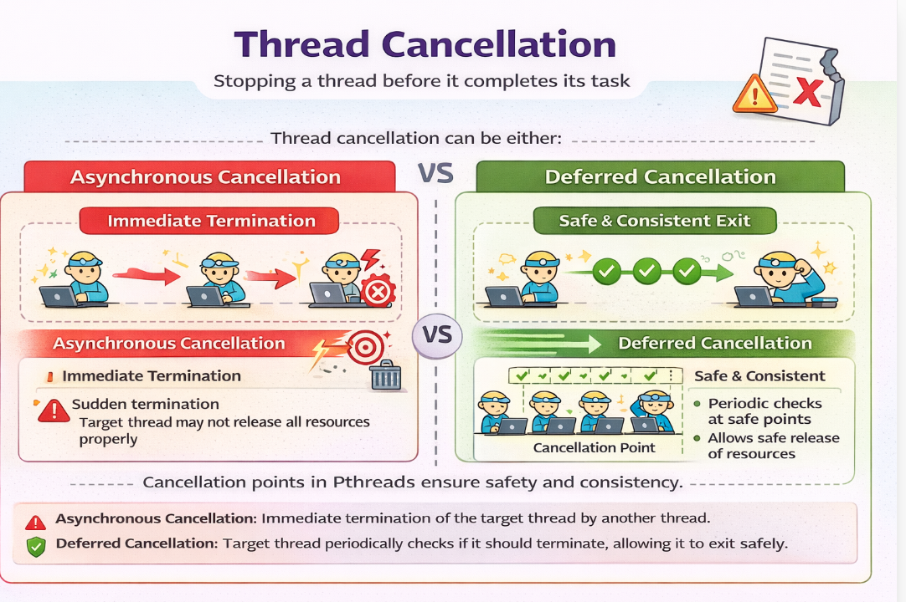

Signal handling in single-threaded systems is simple and direct, whereas in multithreaded systems it becomes complex due to multiple possible handlers and requires proper coordination.

    - Thread-Local Storage
Threads belonging to a process share the data of the process. Indeed, this data sharing provides one of the benefits of multithreaded programming. However, in some circumstances, each thread might need its own copy of certain data.We will call such data thread-local storage (or TLS.) For example, in a transaction-processing system, we might service each transaction in a separate thread. Furthermore, each transaction might be assigned a unique identifier. To associate each thread with its unique identifier, we could use thread-local storage. It is easy to confuse TLS with local variables. However, local variables are visible only during a single function invocation, whereas TLS data are visible across function invocations. In some ways, TLS is similar to static data. The difference is that TLS data are unique to each thread. Most thread libraries—including Windows and Pthreads—provide some form of support for thread-local storage; Java provides support as well.

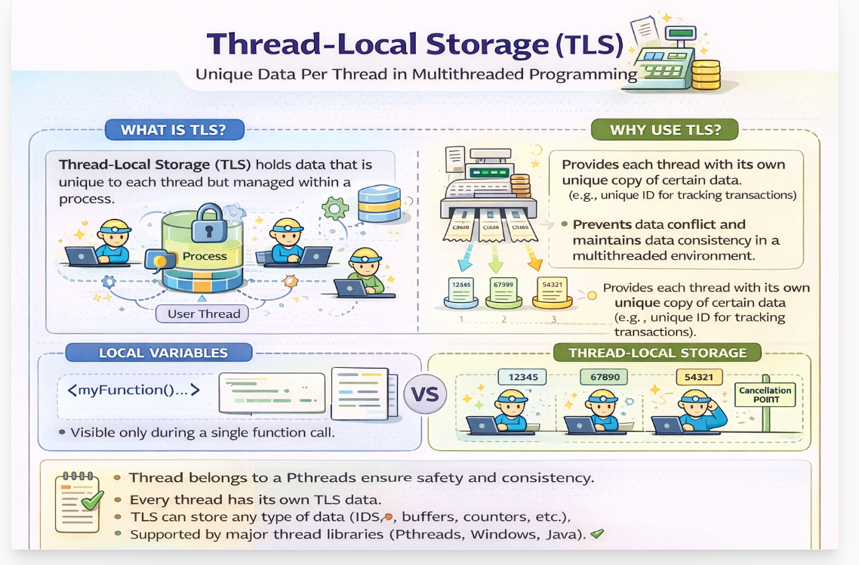

    - Scheduler Activations

A key issue in multithreaded programs is the communication between the kernel and the thread library, especially in systems using the many-to-many or two-level models. This coordination allows for dynamic adjustment of kernel threads, ensuring optimal performance. These models often introduce an intermediate structure called a lightweight process (LWP), which acts as a virtual processor for the user-thread library. The LWP is linked to a kernel thread, and it is the kernel thread that is scheduled on physical processors. If a kernel thread is blocked (e.g., waiting for I/O), the associated LWP and user-level thread also become blocked.

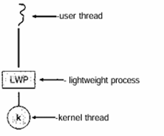

Figure 4.8 Lightweight process (LWP).
An application may require a varying number of LWPs depending on its workload. For example, a CPU-bound application on a single processor only needs one LWP, whereas an I/O-intensive application may require multiple LWPs—one for each blocking system call like simultaneous file reads. If there are fewer LWPs than required, some requests must wait. Scheduler activation enables the kernel to allocate a set of virtual processors (LWPs) to an application, allowing it to schedule user threads. The kernel also uses upcall handler to notify the application about events, like a thread about to block, triggering handlers that manage thread state and scheduling efficiently.

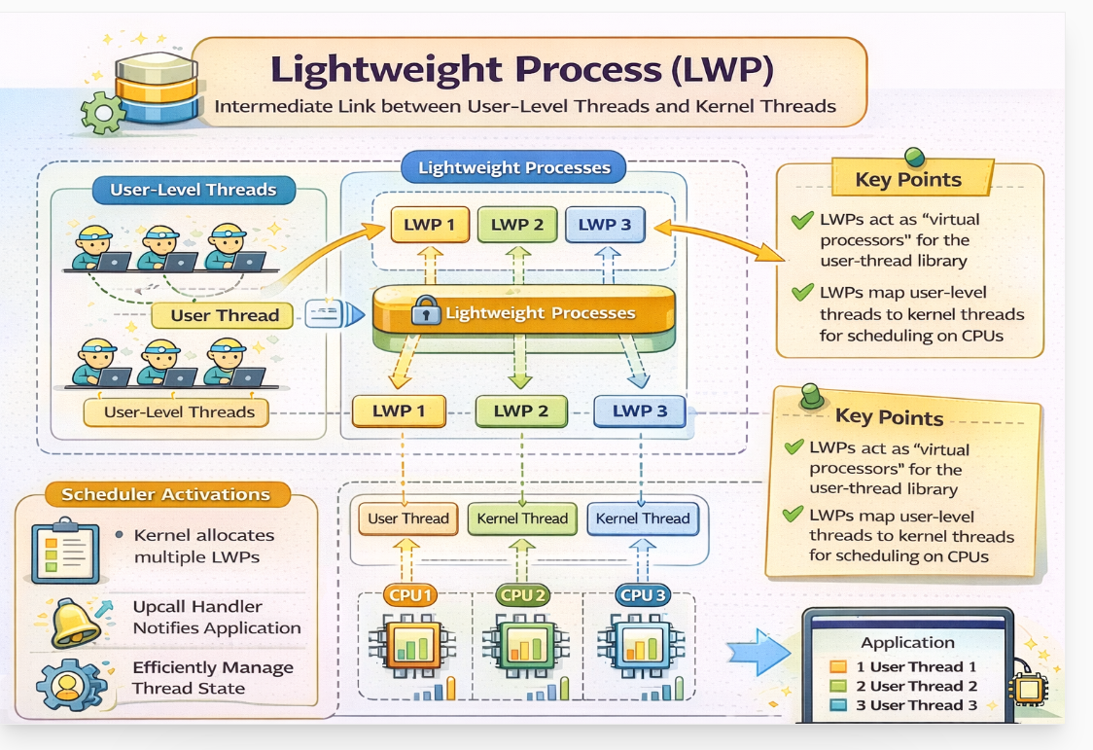

A thread represents a unit of work, while an LWP acts as an intermediate execution entity that maps user threads to kernel threads and ultimately to CPU cores.

Topic | Concept / Definition | Key Points | Types / Variants | Issues / Challenges | Example / Notes
fork() and exec() | System calls used to create and run processes in UNIX systems | - fork() creates a new process (child)- Child may contain one thread or all threads- exec() replaces process memory | - fork (duplicate process)- exec (replace process) | - Inconsistency: whether all threads or one thread is copied- Resource duplication issues | If exec() is called after fork(), only one thread is sufficient
Signal Handling | Signals are notifications sent to a process to handle events | - Used for interrupts/events- Delivered to process/threads- Handled by default or user-defined handler | - Synchronous (same thread, e.g., divide by zero)- Asynchronous (external, e.g., Ctrl+C) | - Difficult to decide which thread should handle signal- Coordination needed among threads | Signal can be sent to one thread, all threads, or a specific handler thread
Cancellation | Terminating a thread before it completes execution | - Used when thread result is no longer needed- Must ensure safe termination | - Asynchronous cancellation (immediate)- Deferred cancellation (safe points) | - Immediate cancellation may cause resource leaks- Improper cleanup leads to inconsistency | Deferred cancellation is preferred (safe termination points)
Thread-Local Storage (TLS) | Mechanism to provide each thread its own private data | - Threads share process memory but may need private data- Data persists across function calls | - TLS variables (per-thread storage) | - Confusion with local variables- Managing separate copies efficiently | Example: Each thread has its own transaction ID
Scheduler Activations | Mechanism to coordinate user-level and kernel-level threads | - Uses Lightweight Process (LWP) as bridge- Kernel provides virtual processors | - Many-to-many model- Two-level model | - Need proper coordination between kernel & thread library- Blocking of kernel thread affects user thread | LWP acts as intermediate between user threads and CPU

